This document will show you how to view the detail of the courses and credits that make up a student’s GPA.
Step 1: Home » SIS » Student » Course History » GPA History
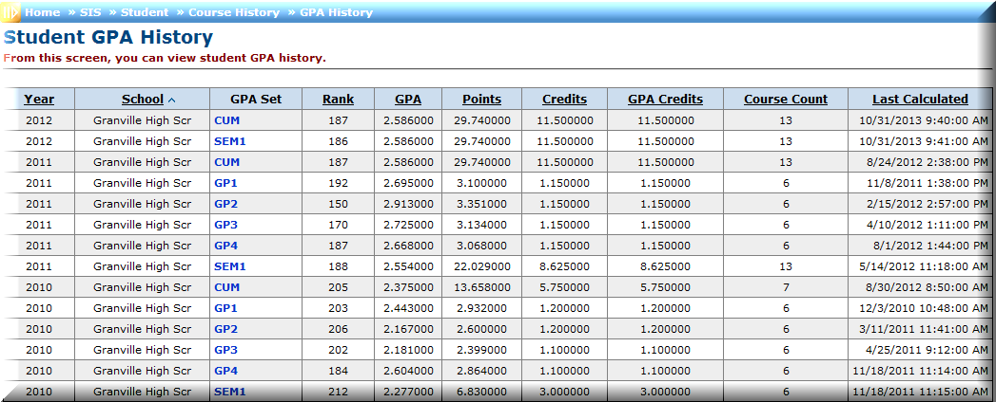
The screen below will list each GPA that has been calculated per school year for the student. Depending on the student and grade level, you will have more or less options to choose from on this page.

Step 2: To view the details of a GPA click on the GPA Set (blue link under GPA Set) you would like to see.
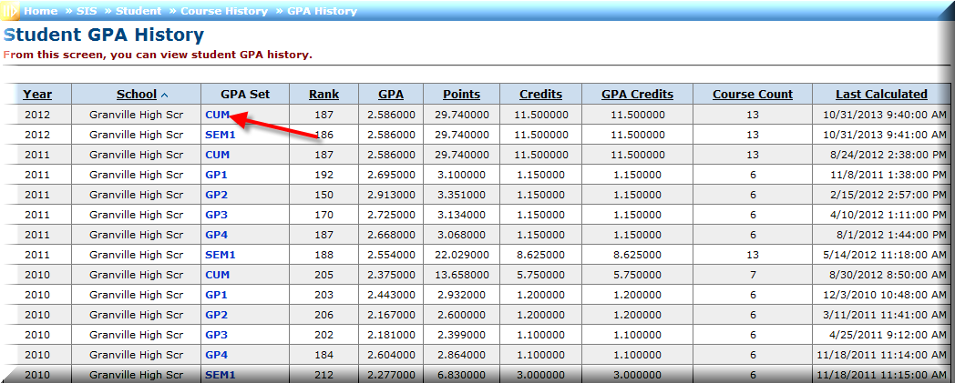

The GPA above is based on the last time the GPA set was refreshed. When you click on the GPA set to see more detail, the system will temporarily refresh the GPA Set, so you may see a difference.

Step 3: The GPA details will list GPA Set that was chosen, the Calculations and the Details. The Calculations will show you the GPA Based on the current GPA configuration and the last time the GPA was recalculated (like we mentioned in the note on page 1). If any changes were made to the GPA, you could see a different GPA listed. The GPA that is accurate will be the Calculation named GPA based on current GPA configuration.
